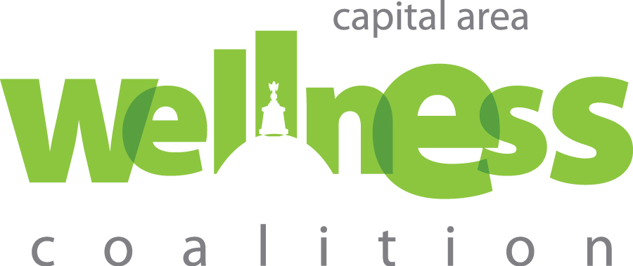

Dear Parents,

We are pleased to announce that we have teamed up with Concord Hospital to implement a healthy eating, active living initiative entitled 5210 Healthy NH.

Creating healthy habits for your child to live by is very important. The 5-2-1-0 Healthy NH message promotes healthy growth and development, through physical activity and healthy eating.



Eating healthy foods and being physically active can be a challenge in today’s busy world. By partnering  
with Concord Hospital, we will be incorporating the 5-2-1-0 Healthy NH messages into  
our daily activities. As a bonus, you may also receive parent-geared information and at-home activities. This will highlight what your child is learning and will provide tips to incorporate the 5-2-1-0 messages in your home.

Visit capwellness.org for more information about 5-2-1-0 Healthy NH.

For more information please contact

Sincerely,